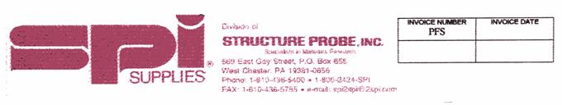
DEBORA MARCHAK  WEIZMANN INSTITUTE | TEL: 08 9342169  CELL : 0545245542  EMAIL: dmarchak@gmail.com  FAX: 0 8

CUSTOMER #  304A/12 |  |  | F.O.B. POINT  West Chester PA. USA |  |  |  | SHIPPED VIA  Advise |  | TERMS  Bank card  Or/pp
QTY.  ORDER | CATALOGUE  NUMBER |  |  | DESCRIPTION |  |  |  | PRICE |  | AMOUNT  In US$
2 | 439HP-AB  466PS-AB  05015-AB |  |  | HOPG 10mm x 10mm x2mm  AU (111) on MICA 1.4cm x 1.1cm one pack of 5  3M MAGIC TAPE |  |  |  | 250.56 |  | 501.12  718.20  5.10
MINIMUM ORDER - $ 50.00 |  |  |  |  |  | ALL PRICES IN US DOLLARS FIRM 30 DAYS.  BANK CHARGES (IF APPLIC-ABLE) FOR PURCHASERS  ACC 19Christmas holiday  15/03/12  Ship 2-6 weeks
A SERVICE CHARGE OF 1 ½ % PER MONTH (18 % PER YEAR) WILL BE CHARGED TO ANY BALANCE OVER 30 DAYS.
THERE IS A RESTOCKING CHARGE ON ALL ITEMS ORDERED IN ERROR. BILLING WILL INCLUDE INITIAL SHIPPING COSTS. RETURN CHARGES ARE TO BE PREPAID.
Terms of payment: credit card or check with the order.
Delivery: ups/dhl 72 us$
App 35us$
Flammable
SPT 3000 P.O.Box 16499 Tel-Aviv, 61164 – Israel
email: info_spt@netvision.net.il
tel 03 6966174 fax 03 6915938 sell 0544 220636

RAFAEL THALER

